Landmark Varieties:
NRCP-Varieties:
Variety | Year of Release/ Notification | Characteristic
Pomegranate var. Solapur Lal | 2022- 52nd SSSC Meeting , Mumbai  (SVRC)  CVRC meeting held online on -5th August, 2024 | - Climate resilient, bio-fortified pomegranate variety, Solapur Lal  - It readily responds to crop regulation (Bahar treatment ) with regular flowering and better fruitset and less flower drop ;  - It matures in about 160 days; TSS > 17.6º Brix; Ascorbic acid: 19. 4 mg/100g  - Yield about 35 kg/tree, 25 t/ha,  - Registered with PPV& FRA, New Delhi (PPV&FRA/REG/2016/1747)
Pomegranate var. Solapur Anardana | 2024- 53rd SSSC Meeting , Mumbai  (SVRC)  CVRC meeting held online on 5th August, 2024 | - Purpose: Suitable for ‘Anardana purpose’  - High Yielding Variety: about 20-22 tons/ ha, Titrable Acidity: 4.8%; High anthocyanin: 460mg/100g ; Anardana recovery from arils : 21.6%  - Fruit maturity: 148-150 days.  - Registered with PPV& FRA, New Delhi (PPV&FRA/REG/2016/1750)  - This is one of the 109 bio-fortified varieties dedicated to the Nation by the Hon’ble PM of India on 11.08.2024.
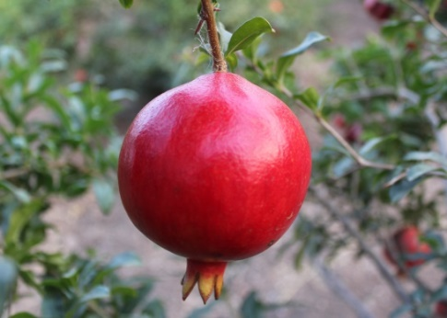 | 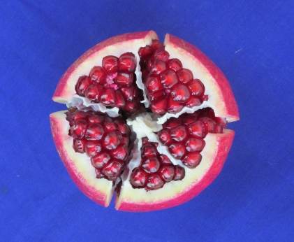
Pomegranate var. Solapur Lal

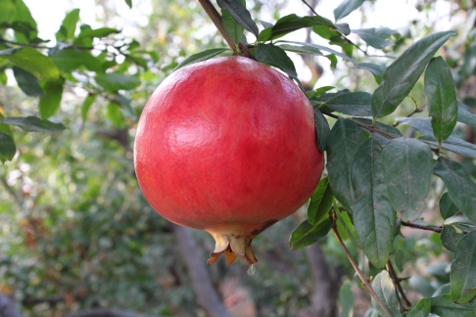 | 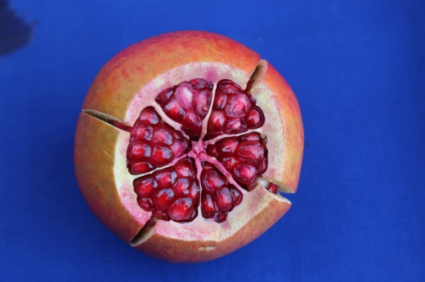
Pomegranate var. Solapur Anardana

- PPV& FRA Registration of pomegranate varieties developed by ICAR-NRCP:
- Pomegranate var. NRCP H-14: PPV&FRA/REG/2016/1748. Date of Grant: 12.12.2023. ITMU/ VTIC identified 2022 ; Pink aril variety for table purpose; Higher TSS-17.8 Brix;
- Pomegranate var. NRCP H-4 : PPV&FRA/REG/2016/1749. Date of Grant: 12.12.2023 ITMU/ VTIC identified 2022; Pink aril variety for anardana purpose; Higher TA: 5.6%.

Traditional Varieties:
GI Tagged Varieties: Geographical Indicator (GI) tag for pomegranates from Solapur region of India.

