• Biofortified Varieties:
- Pomegranate varieties Solapur Lal:
Variety | Year of Release/ Notification | Characteristic
Pomegranate var. Solapur Lal | 2022- 52nd SSSC Meeting , Mumbai  (SVRC)  CVRC Notified -2024: Sl. No. 135 Gazette Notification of India no.4536 released by MoA & FW GoI dated. 13.11.2024. | - Climate resilient, bio-fortified pomegranate variety, Solapur Lal  - It readily responds to crop regulation (Bahar treatment ) with regular flowering and better fruitset and less flower drop ;  - It matures in about 160 days; TSS > 17.6º Brix; Ascorbic acid: 19. 4 mg/100g  - Yield about 35 kg/tree, 25 t/ha,  - It has more iron and zinc as compared to the ruling variety Bhagwa.  - Registered with PPV& FRA, New Delhi (PPV&FRA/REG/2016/1747)

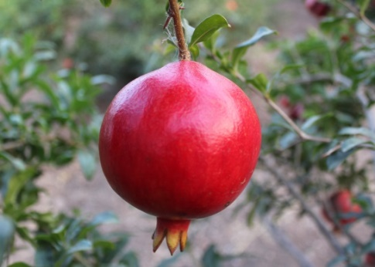 | 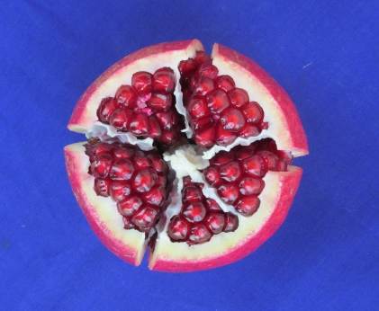
Pomegranate var. Solapur Lal

