Profile
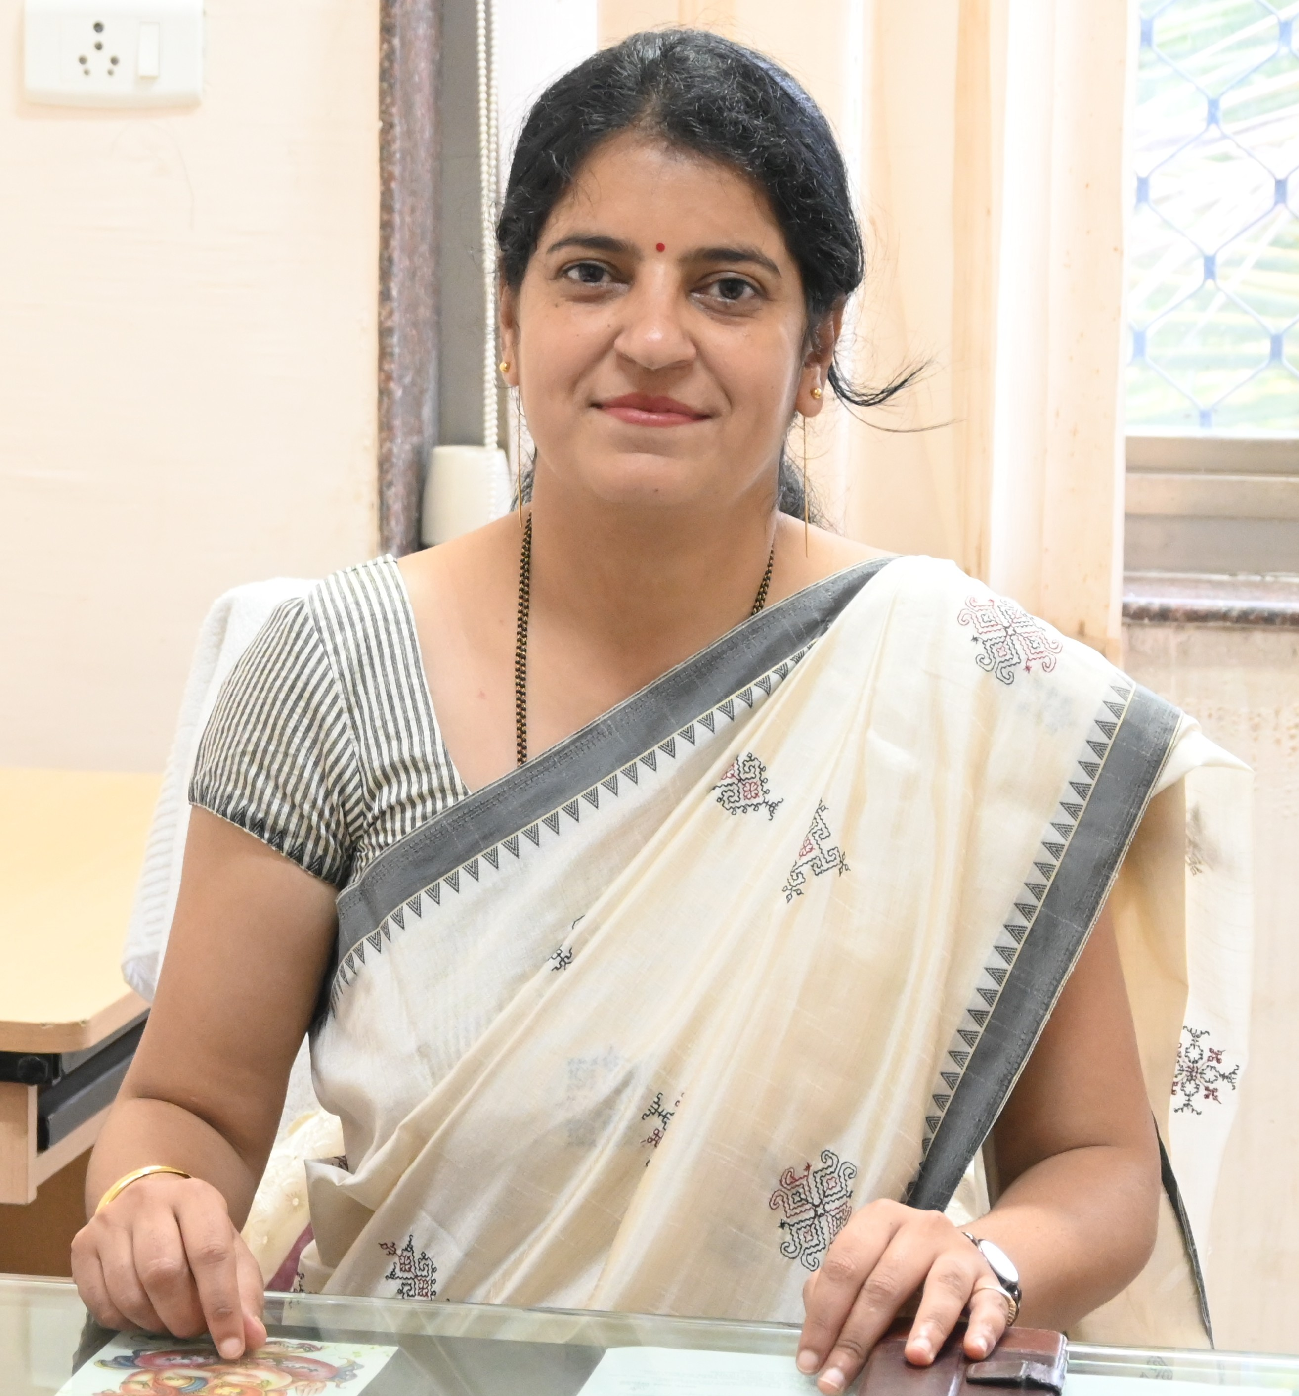

- Name : Dr. Pinky Raigond
- Designation : Senior Scientist
- Email : jariapink@gmail.com
- Phone Number: Extension:
- Academic Qualification:
- Ph.D.- Plant Physiology (2010)
- M.Sc.- Plant Physiology (2006)
- B.Sc.- 2004
- Joining date in ICAR (dd/mm /yyyy): 28 April 2010 at Central Potato Research Institute, Shimla

- Joining date at ICAR-NRCP, Solapur: 04 October 2021

- Area of Research:
Management of abiotic stresses and major physiological disorders in pomegranate

- Publications (Best 10 having high NAAS rating)
- Thakur N, Raigond P*, Singh Y, Mishra T, Singh B, Lal MK, Dutt S (2020) Recent updates on bioaccessibilities of phytonutrients. Trends in Food Science and Technology 97: 366-380. https://doi.org/10.1016/j.tifs.2020.01.019
- Raigond P*, Jayanaty SS, Parmar V, Dutt S, Changan SS, Luthra SK, Singh B (2023) Health-Promoting Compounds In Potatoes: Tuber Exhibiting Great Potential For Human Health. Food Chemistry. https://doi.org/10.1016/j.foodchem.2023.136368
- Singh, A., Raigond, P*, Lal, M.K., Singh, B., Thakur, N., Changan, S.S., Kumar, D., Dutt, S. 2020. Effect of cooking methods on glycemic index and in vitro bioaccesibility of potato (Solanum tuberosum L.) carbohydrates. LWT-Food Sci. Technol. 127: 109363. https://doi.org/10.1016/j.lwt.2020.109363
- Raigond, P*., Kaundal, B., Sood, A., Devi, S., Dutt, S., Singh, B. 2018. Quantification of biguanide and related compounds (anti-diabetic) in vegetables and fruits. J. Food Compos. Anal. 74: 82-88. https://doi.org/10.1016/j.jfca.2018.09.001
- Raigond P*, Sowjanya PR, More AK, Zodage SD, Gawade NS, Parashuram S, Giri NA, Patil PG, Babu KD, Marathe RA (2025) Morpho-nutritional diversity for biofortification traits to enhance fruit quality in pomegranate (Punica granatum L.), J. Food Comp. Anal., 141, 107343.
- Raigond P*, N. V. Singh, Amarja K. More, Shilpa Parashuram, Namrata A. Giri, Chandrakant Awachare, P. Roopa Sowjana, Prakash Patil, Dhinesh K Babu, Rajiv A. Marathe* (2024) Impact of PGRs, polyamines and potassium to improve pomegranate flowering behaviour, fruit set and fruit quality. Biocatal. Agric. Biotechnol. 61(1):103355. DOI: 10.1016/j.bcab.2024.103355
- Raigond P*, Bhardwaj P, Raigond B, Parmar V, Dutt S, Singh B (2024) Unveiling the presence of insulin-like antidiabetic proteins in potato: A wholesome food. Biocatal. Agric. Biotechnol. DOI:10.1016/j.bcab.2024.10317710.0
- Raigond, P*, Singh B, Dhulia A, Chopra S, Dutt S (2015) Flavouring compounds in Indian potato snacks. J. Food Sci. Tech. 52(12) : 8308–8314.
- Thakur N, Raigond P*, Jayanty SS, Goel G, Dutt S, Singh B (2022) Compositional Changes in Potato Carbohydrates and Polyphenols during In vitro Gastrointestinal Digestion. Starch - Stärke, 74 (9-10): 2200036. https://doi.org/10.1002/star.202200036
- Raigond P*, Parmar V, Thakur A, Lal MK, Changan SS, Kumar D, Dutt S, Singh B (2021) Composition of Different Carbohydrate Fractions in Potatoes: Effect of Cooking and Cooling. Starch – Stärke, 73: 2100015. DOI: 10.1002/star.202100015

- Patent / Technologies / Varieties / Methodologies / System etc. (Five only) :
Potato Varieties
- Kufri Neelkanth
- Kufri Jamunia
- Kufri Karan
- Kufri Lohit
- Unique potato germplasm registered:
    - MSH/17-16 (Nitrogen Use Efficient)
    - NUE/15-8 (Nitrogen Use Efficient)
    - MSP/15-26 (Carotenoids rich)
    - MSP/15-51 (Ascorbic acid rich)
    - MS/8-1148 (Ascorbic acid rich)

- Awards / Recognitions / Fellowship (Five only) :
- NAAS-Associate (Horticulture); National Academy of Agricultural Sciences- Associateship awarded in 2023
- R.H. Dastur Gold Medal Award conferred by Indian Society for Plant Physiology in 2023 during National Conference of Plant Physiology -2023
- IPA-Chandra Prabha Singh Young Scientist Award for the year 2022 conferred by Indian Potato Association
- ICAR-CPRI Best Worker Award (Scientific Category) for the year 2021 conferred by ICAR-Central Potato Research Institute, Shimla, H.P.
- Young Achiever Award- 2019 conferred by Society for Advancement of Human and Nature (SADHNA), DR YS Parmar University of Horticulture and Forestry
Nauni, Solan Himachal Pradesh.

